SWT 22022 – Practical for Internet Application Development
Department of Information and Communication Technology
Faculty of Technology
Lab sheet :19
Reg. Number: SEU/IS/20/ICT/084
Academic Year :2020/2021
Date: 2024.10.30
Practical No :20

Title:
- React Routes and API
Aims:
• Creating a dynamic list
• Using context to share data between components
• Building a simple routing system
• API and Axios
Tasks:
• Use useState to manage list
• Use Context API to pass data between components without props drilling.
• Use React Router for client-side routing
• Use Axios to fetch data from an API
Activities :
- Use useState to manage list

import { useState } from 'react';
const DynamicList = () => {
const [items, setItems] = useState([]);
const addItem = () => setItems([...items, `Item ${items.length + 1}`]);
return (
<div>
<button onClick={addItem}>Add Item</button>
<ul>{items.map((item, index) => <li key={index}>{item}</li>)}
</ul>
</div>
);
};
export default DynamicList;
2. Use Context API to pass data between components without props drilling.
a. ContextProvider.jsx
import { createContext, useState } from 'react';
export const MyContext = createContext();
const ContextProvider = ({ children }) => {
const [sharedData, setSharedData] = useState("Initial Data");
return (
<MyContext.Provider value={{ sharedData, setSharedData }}>{children}</MyContext.Provider>
);
};
export default ContextProvider;

b. ComponentNew.jsx
import { useContext } from 'react';
import { MyContext } from './ContextProvider';
const ComponentNew = () => {
const { sharedData, setSharedData } = useContext(MyContext);
return (
<div>
<p>{sharedData}</p>
<button onClick={() => setSharedData("Updated Data")}>Update</button>
</div>
);
};
export default ComponentNew;

3. Use React Router for client-side routing
Install React Router :
npm install react-router-dom
- Home.jsx

const Home = () => {
return <h2>Home</h2>;
};
export default Home;
- About.jsx

const About = () => {
return <h2>About</h2>;
};
export default About;

- AppRoutes.jsx

import { Routes, Route } from 'react-router-dom';
import Home from './Home';
import About from './About';
const AppRoutes = () => {
return (
<Routes>
<Route path="/" element={<Home />} />
<Route path="/about" element={<About />} />
</Routes>
);
};
export default AppRoutes;
- App.jsx

import { BrowserRouter as Router, Link } from 'react-router-dom';
import AppRoutes from './AppRoutes';
const App = () => (
<Router>
<nav>
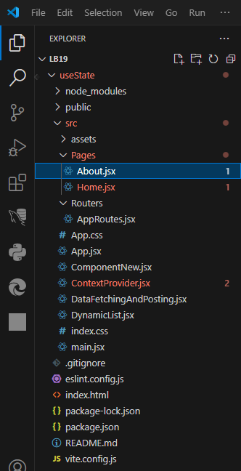
<Link to="/">Home</Link>
<Link to="/about">About</Link>
</nav>
<AppRoutes />
</Router>
);
export default App;

About.jsx

const About = () => {
return (
<div>
<h2>This is About Page Content</h2>
<h1>What is Lorem Ipsum?</h1>
<p>Lorem Ipsum is simply dummy text of the printing and typesetting industry. Lorem Ipsum has been the industry's standard dummy text ever since the 1500s, when an unknown printer took a galley of type and scrambled it to make a type specimen book. It has survived not only five centuries, but also the leap into electronic typesetting, remaining essentially unchanged. It was popularised in the 1960s with the release of Letraset sheets containing Lorem Ipsum passages, and more recently with desktop publishing software like Aldus PageMaker including versions of Lorem Ipsum.</p>
</div>
);

};
export default About;

Home.jsx

const About = () => {
return (
<div>
<h2>This is About Page Content</h2>
<h1>What is Lorem Ipsum?</h1>
<p>Lorem Ipsum is simply dummy text of the printing and typesetting industry. Lorem Ipsum has been the industry's standard dummy text ever since the 1500s, when an unknown printer took a galley of type and scrambled it to make a type specimen book. It has survived not only five centuries, but also the leap into electronic typesetting, remaining essentially unchanged. It was popularised in the 1960s with the release of Letraset sheets containing Lorem Ipsum passages, and more recently with desktop publishing software like Aldus PageMaker including versions of Lorem Ipsum.</p>
</div>
);

};
export default About;

DynamicList.jsx

import { useState } from 'react';

const DynamicList = () => {
const [items, setItems] = useState([]);
const addItem = () => setItems([...items, `Item ${items.length + 1}`]);

return (
<div>
<button onClick={addItem}>Add Item</button>
<ul>{items.map((item, index) => <li key={index}>{item}</li>)}</ul>
</div>
);
};

export default DynamicList;

ContextProvider.jsx
import { useState } from 'react';

const DynamicList = () => {
const [items, setItems] = useState([]);
const addItem = () => setItems([...items, `Item ${items.length + 1}`]);

return (
<div>
<button onClick={addItem}>Add Item</button>
<ul>{items.map((item, index) => <li key={index}>{item}</li>)}</ul>
</div>
);
};

export default DynamicList;
ComponentNew.jsx

import { useContext } from 'react';
import { MyContext } from './ContextProvider';
const ComponentNew = () => {
const { sharedData, setSharedData } = useContext(MyContext);
return (
<div>
<p>{sharedData}</p>
<button onClick={() => setSharedData("Updated Data")}>Update</button>
</div>
);
};
export default ComponentNew;

AppRoutes.jsx

import { Routes, Route } from 'react-router-dom';
import Home from '../Pages/Home';
import About from '../Pages/About';
const AppRoutes = () => {
return (
<Routes>
<Route path="/" element={<Home />} />
<Route path="/about" element={<About />} />
</Routes>
);
};
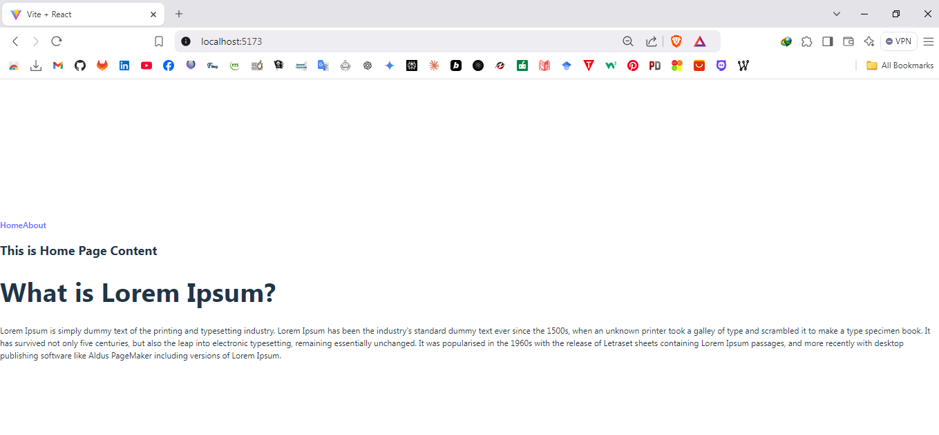
export default AppRoutes;

4. Use Axios to fetch data from an API
Install Axios :
npm install axios

- DataFetchingAndPosting.jsx

import { useEffect, useState } from 'react';
import axios from 'axios';
const DataFetchingAndPosting = () => {
const [data, setData] = useState([]);
const [newPost, setNewPost] = useState({
title: '',
body: '',
userId: 1
});
// GET request to fetch data
useEffect(() => {
axios.get('https://jsonplaceholder.typicode.com/posts').then(response => setData(response.data)).catch(error => console.error(error));
}, []);
// POST request to add new data
const handlePost = () => {
axios.post('https://jsonplaceholder.typicode.com/posts',newPost).then(response => {
console.log('New Post Added:', response.data);
setData([...data, response.data]);
}).catch(error => console.error(error));
};
return (
<div>
<h3>Data Fetching (GET Request)</h3>
<ul>{data.map(post => <li key={post.id}>{post.title}</li>)}</ul>
<h3>Add a New Post (POST Request)</h3>
<input type="text" placeholder="Title" value={newPost.title} onChange={e => setNewPost({ ...newPost, title: e.target.value })}/>
<input type="text" placeholder="Body" value={newPost.body} onChange={e => setNewPost({ ...newPost, body:e.target.value })}/>
<button onClick={handlePost}>Add Post</button>
</div>
);
};
export default DataFetchingAndPosting;

- App.jsx

import DataFetchingAndPosting from './DataFetchingAndPosting';
function App() {
return (
<>
<DataFetchingAndPosting />
</>
);
}
export default App;

DataFetchingAndPosting.jsx

import { useEffect, useState } from 'react';
import axios from 'axios';
const DataFetchingAndPosting = () => {
const [data, setData] = useState([]);
const [newPost, setNewPost] = useState({
title: '',
body: '',
userId: 1
});
// GET request to fetch data
useEffect(() => {
axios.get('https://jsonplaceholder.typicode.com/posts').then(response => setData(response.data)).catch(error => console.error(error));
}, []);
// POST request to add new data
const handlePost = () => {
axios.post('https://jsonplaceholder.typicode.com/posts',newPost).then(response => {
console.log('New Post Added:', response.data);
setData([...data, response.data]);
}).catch(error => console.error(error));
};
return (
<div>
<h3>Data Fetching (GET Request)</h3>
<ul>
{data.map(post => <li key={post.id}>{post.title}</li>)}
</ul>
<h3>Add a New Post (POST Request)</h3>
<input type="text" placeholder="Title" value={newPost.title} onChange={e => setNewPost({ ...newPost, title: e.target.value })}/>
<input type="text" placeholder="Body" value={newPost.body} onChange={e => setNewPost({ ...newPost, body: e.target.value })}/>
<button onClick={handlePost}>Add Post</button>
</div>
);
};
export default DataFetchingAndPosting;

App.jsx

import DataFetchingAndPosting from './DataFetchingAndPosting';
function App() {
return (
<>
<DataFetchingAndPosting />
</>
);
}
export default App;

Discussion:
  - In this lab session on React Routes and API integration, we explored fundamental concepts to build dynamic and interactive web applications. The session focused on creating a dynamic list using the useState hook to manage component-level state effectively. We utilized the Context API to share data seamlessly between components, avoiding the complexity of props drilling. This approach not only simplifies state management but also enhances the maintainability of the code. React Router was introduced to set up client-side routing, enabling smooth navigation between multiple pages like "Home" and "About." Additionally, we learned to fetch data from an API using Axios, demonstrating both GET requests for data retrieval and POST requests to add new entries dynamically. Overall, the session provided a hands-on understanding of core React functionalities and their application in building scalable web applications.

